HR ANALYTICS – EMPLOYEE WORKFORCE, ATTRITION, PERFORMANCE & ENGAGEMENT ANALYSIS

1. Project Overview and Objective
This project analyses employee-related data using Microsoft Excel and Power BI. The workbook contains employee master information and related records for performance reviews, training, leave and attendance, and engagement surveys. The data is prepared and modelled to create interactive dashboards that help understand workforce composition, employee exits, performance and training outcomes, and employee engagement and leave patterns.

The main objective is to demonstrate an end-to-end data analytics workflow: inspect and clean raw data, standardise fields, establish relationships between related tables, create DAX measures, and present meaningful HR metrics through interactive Power BI report pages. The report is intended to support descriptive analysis and help HR teams identify areas that may need further investigation.

2. Data Sources
- Source description: https://excelx.com/practice-data/generators/hr-analytics/,
- From here I extracted 800 rows uncleaned data.
- The dataset contains five related tables: Employee master, Performance Reviews, Traini Records, Leave Attendance and Engagement Surveys.
- Domain: Human Resources (HR) Analytics. The analysis covers employee workforce information, attrition, performance reviews, training, leave/attendance and employee engagement.

3. Problem Statement
- To understand the organisation's workforce composition by department, gender, job title and employment status.
- To measure employee exits and examine attrition patterns across departments, job titles, gender and termination dates.
- To evaluate employee performance review scores and training outcomes across departments and courses.
- To examine employee satisfaction, work-life balance, manager feedback and leave patterns to identify areas for HR review.

4. Attribute (Column / Features) Details
Attribute Name | Data Type | Description
EmployeeID | Text / Integer | Employee identifier used to connect employee records across tables.
Full name | Text | Employee name stored in the employee master table.
Department | Text / Category | Department to which the employee or related record belongs.
Gender | Text / Category | Employee gender category recorded in the employee master.
Hire Date | Date | Date the employee joined the organisation.
Termination Date | Date | Employee exit date; blank for employees without a recorded termination date.
Status | Text / Category | Employment status, such as Active or Terminated.
Job Title | Text / Category | Employee's job title or role.
Salary | Decimal / Currency | Employee salary value.
OverallScore | Decimal | Overall performance review score.
Communication / Teamwork / Problem Solving | Numeric | Individual skill-related scores recorded in performance reviews.
Course Name | Text / Category | Name of the training course.
Completion Date | Date | Date associated with the training record/course completion.
Score | Decimal | Score recorded for the training record.
Leave Type | Text / Category | Category/type of leave recorded.
Leave Days | Numeric | Number of leave days in the leave/attendance record.
Overall Satisfaction | Numeric | Employee overall satisfaction survey score.
WorkLife Balance | Numeric | Employee work-life balance survey score.
Manager Satisfaction | Numeric | Employee rating/score relating to manager satisfaction or feedback.

5. Tools & Technologies
- Microsoft Excel: Initial data inspection, cleaning, handling missing values, checking duplicates, standardising formats and validating employee identifiers.
- Microsoft Power BI: Power Query transformation, data modelling, DAX measures, interactive visualisations, slicers, filtering and dashboard/report creation.

6. Data Pre-Processing (Excel / Power Query)
Tasks performed:
- Data inspection and cleaning: Reviewed the five tables for blank/null values, N/A entries, duplicate records, inconsistent text and data-type issues. Missing values were assessed according to the meaning of each field; employee identifiers were checked against the employee master rather than replaced without validation.
- Standardisation and validation: Standardised column names and data types, checked date fields, trimmed unwanted spaces where required, and reviewed employee IDs across related tables. Repeated EmployeeID values in all other tables were retained where multiple records per employee were valid.
- Data preparation: Used Excel and/or Power Query to filter, sort, inspect and summarise records.
- Table organisation: Retained the employee master table as the employee reference table and used the performance, training, leave/attendance and engagement tables as related record tables. This structure supports analysis without incorrectly removing legitimate repeated employee IDs from tables containing multiple records per employee.

7. Data Modelling and DAX (Power BI)
- Data model: The report uses Employee master as the central employee table linked to Performance Reviews, Training Records, Leave Attendance and Engagement Surveys through the employee identifier. Confirm that Employee master [EmployeeID] is unique and that the employee identifier has a consistent data type in all tables. Use one-to-many relationships, verified cardinality before setting up relationships.
Power BI Model view showing the five related tables and their relationships.
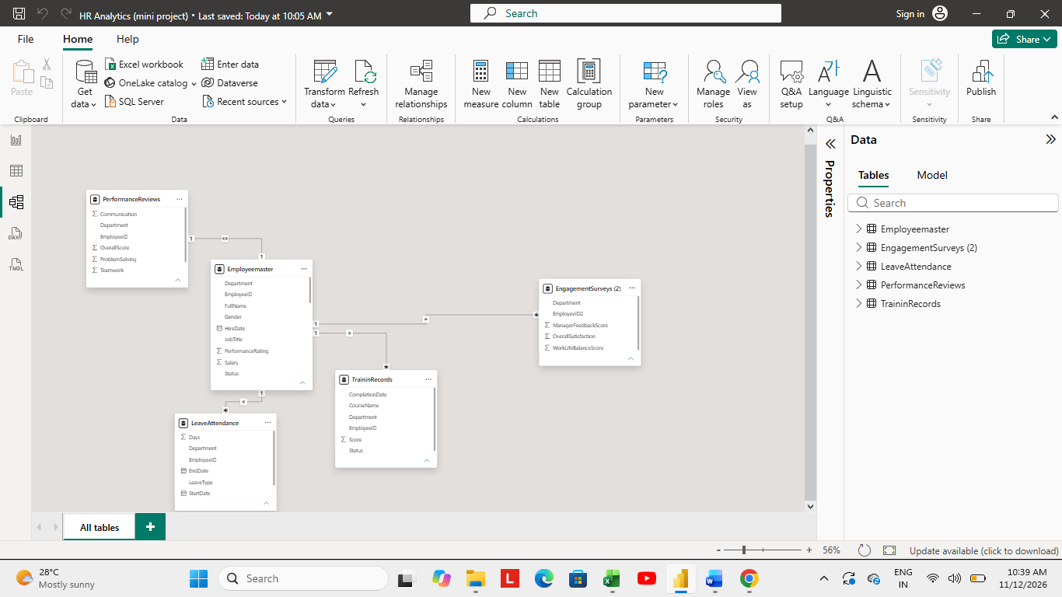
- DAX measures used:
Total Employees = DISTINCTCOUNT (Employeemaster [EmployeeID])
Active Employees = CALCULATE([Total Employees], Employeemaster[Status] = "Active")
Attrition Count = CALCULATE([Total Employees], Employeemaster[Status] = "Terminated")
Termination Share = DIVIDE([Attrition Count], [Total Employees], 0)
Average Salary = AVERAGE(Employeemaster[Salary])
Total Departments = DISTINCTCOUNT(Employeemaster[Department])
Total Performance Reviews = COUNTROWS(PerformanceReviews)
Average Performance Score = AVERAGE(PerformanceReviews[OverallScore])
Employees Trained = DISTINCTCOUNT(TrainingRecords[EmployeeID])
Average Training Score = AVERAGE(TrainingRecords[Score])
Total Leave Records = COUNTROWS(LeaveAttendance)
Total Leave Days = SUM(LeaveAttendance[LeaveDays])
Average Satisfaction = AVERAGE(EngagementSurveys[OverallSatisfaction])
Average Work-Life Balance = AVERAGE(EngagementSurveys[WorkLifeBalance])

8. Analysis and Visualizations (Power BI)
Dashboard pages and features:
Page 1 – Workforce Overview: KPI cards for total employees, active employees, terminated employees, average salary and total departments; charts for employees by department, gender distribution, employee status, average salary by department, employees by job title and hiring trend.
Page 2 – Employee Attrition Analysis: KPI cards for attrition count, termination share/attrition metric, active employees and average exit tenure; charts for attrition by department, attrition by job title, attrition by gender and monthly/year-wise employee exits.
Page 3 – Performance & Training Analysis: KPI cards for total performance reviews, average performance score, employees trained and average training score; charts for average performance by department, performance skill scores and training results/course analysis.
Page 4 – Employee Engagement & Leave Analysis: KPI cards for total leave records, average satisfaction and average work-life balance; charts for leave by department, monthly leave trend, leave distribution by type, satisfaction distribution, work-life balance by department and manager feedback by department.
- Added page-level slicers for relevant fields such as Department, Gender, Status, Job Title, Course, Leave Type and date fields where available. Also Added drill down, filters and bookmarks like clear all filters.
- Used clear page headings, descriptive visual titles, data labels where useful, consistent colour formatting and a common theme across the report.
screenshots of each completed dashboard page (Workforce Overview, Employee Attrition, Performance & Training, and Engagement & Leave).
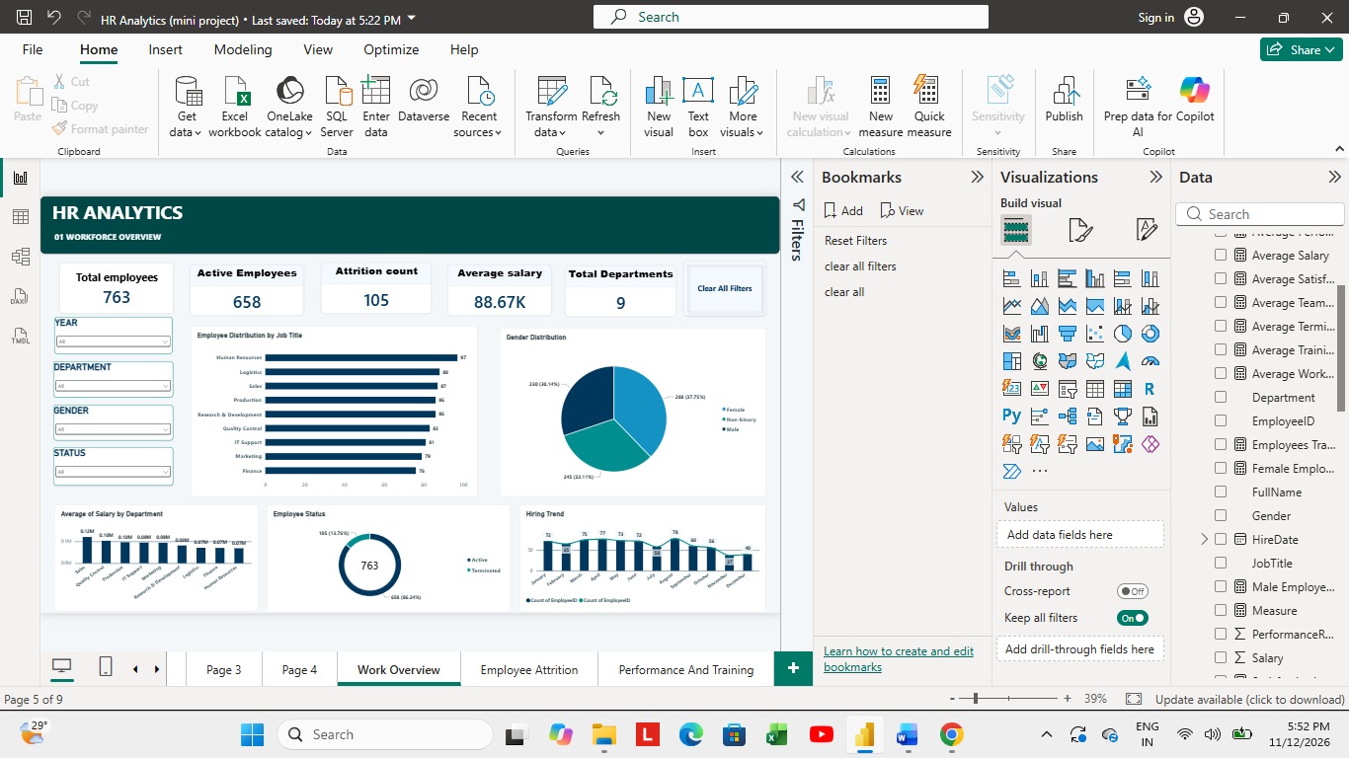
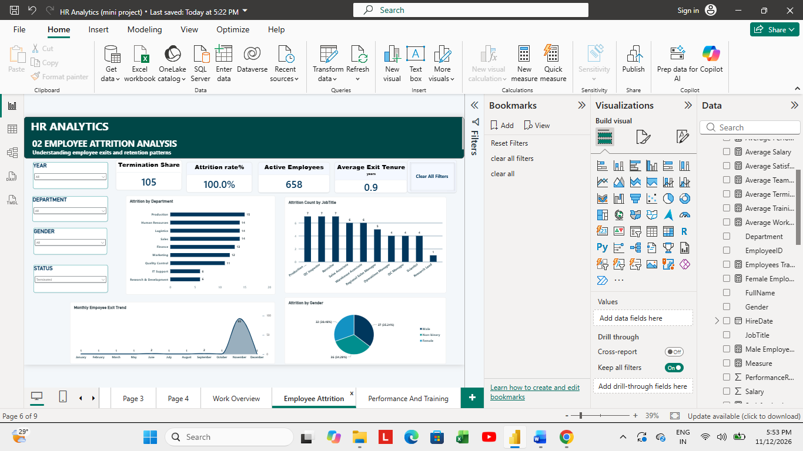

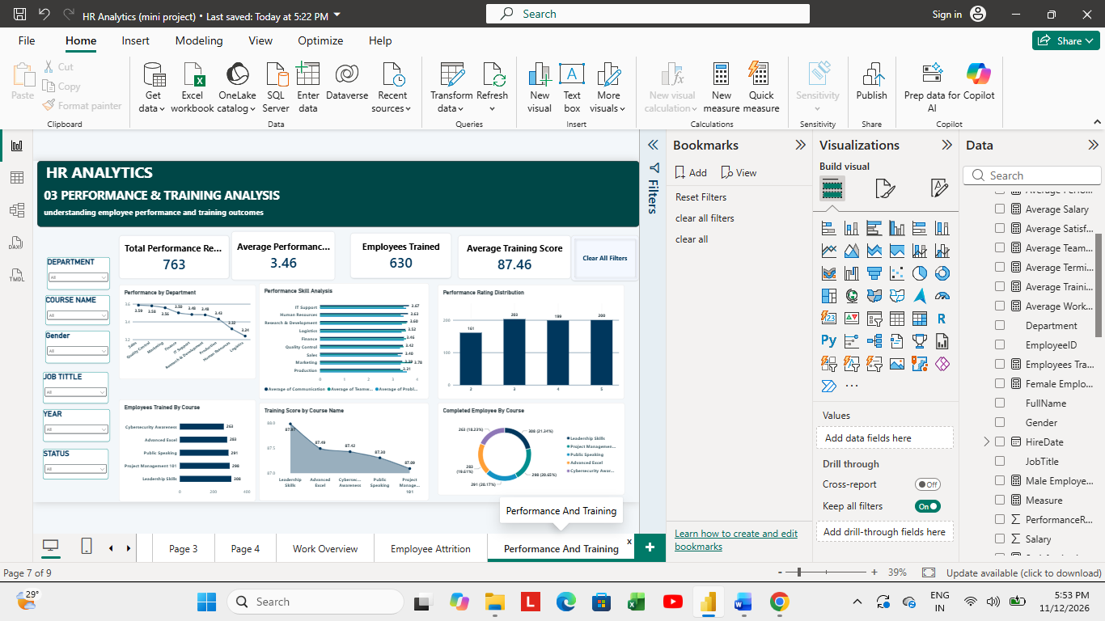

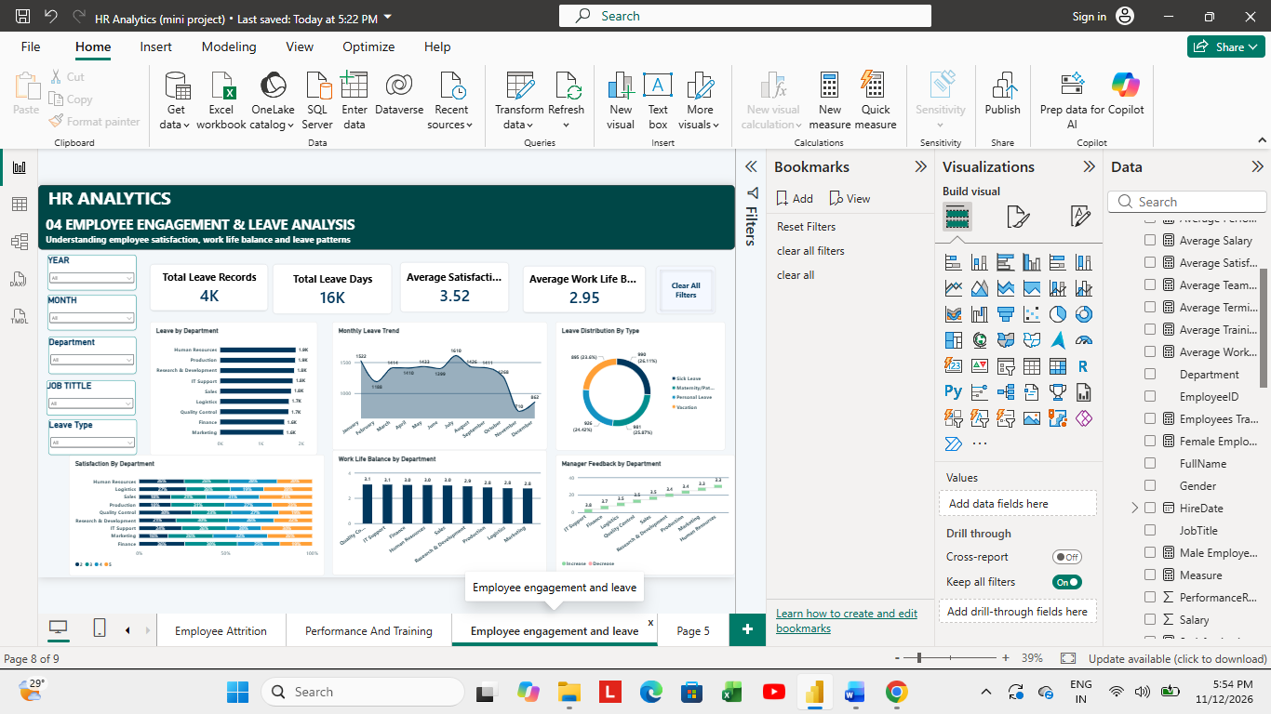

9. Insights & Conclusions
- Key findings to report from the completed dashboard: the employee master contains 763 employees, including 658 active and 105 terminated employees, across 9 departments. The resulting cumulative termination share is approximately 13.8%. The report also calculates performance, training, leave and engagement measures. Interpreted department-level differences.
- Analysis insights:
    - Descriptive: Summarises workforce size and composition, employee exits, performance scores, training scores, leave records, satisfaction and work-life balance.
    - Diagnostic: Enables comparison across departments, job titles, gender, course categories and time periods to identify where differences or unusual patterns occur. The dashboard highlights patterns for investigation.
    - Predictive: My project is primarily descriptive and diagnostic. No predictive model has been built.
    - Prescriptive: HR teams can use the findings to decide where to investigate further—for example, departments with comparatively high exits, training areas with lower scores, or engagement dimensions needing attention. Any action should be based on validated records and follow-up with HR stakeholders.
10. Conclusions
The project demonstrates how Excel and Power BI can be used together for an end-to-end HR analytics workflow. Data preparation, relationship modelling, DAX calculations and interactive dashboards convert multiple HR tables into a consolidated view of workforce, attrition, performance, training, engagement and leave. The resulting report supports data-informed HR review while also showing the importance of data quality, correct relationships and careful interpretation of metrics.

